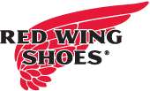
To do our part in battling the COVID-19 pandemic, Red Wing Shoe Company is committed to following all CDC and governmental regulations and recommendations, including any required store closures. As a provider of safety footwear, we are classified as "Personal Protective Equipment" and thus deemed as being essential.

As a result, we will remain OPEN, however are conducting phone-in only business which includes new services to ship-to-home, ship-to-job site or schedule curbside pick-up. We will also have temporary reduced hours of
﻿Mon.-Fri.: 10am-6pm, Saturday: 9am-4pm and closed Sunday.
Please feel free to call us with any questions at
419-893-8647. Thank you and stay safe!

